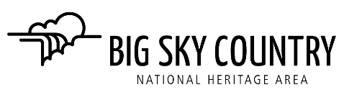

AGENDA - BOARD MEETING
BOARD OF DIRECTORS, BIG SKY COUNTRY NHA, INC.
Monday December 19, 2022

- Call to Order, Welcome Guests and Roll Call Jane Weber

- Disclosure of any Conflicts of Interest on this agenda Board Members

- Consent Agenda Board Members 10 minutes
- Approval of the Meeting Minutes from November 28, 2022
- Ratification of Exec. Committee Actions Taken Between Meetings
- DECISION - January 2023 Meeting and Agenda Bill Bronson 15 minutes

- Old Business
- Nominations Committee Report (Mark Good, Mary Willmarth, Ken Robison) 10 minutes
- Information - Recommend a Slate of Board Members – renewals
- Decision – Acceptance of non-renewals
- Information – Recommendation for a Slate of Officers for 2023 – Chairman, Vice-Chairman, Secretary, Treasurer
- Information – Recommendations of new board members
- Decision – Recommendation of potential new board members to contact

- 2023 Budget Pam Guschausky 10 minutes
- Decision – 2023 Budget Recommendations/modifications

- Committee Reports Committee Chairs

- Finance Committee Pam Guschausky 5 minutes
Members: P. Guschausky (CHAIR), Murry Moore, Bill Bronson
- Information – review of financial statements and year-end giving

- Feasibility Study Task Force Jane Weber 5 minutes
Members: J. Weber (CHAIR), E. Sievert, L. Scriver-Colburn, B. Bronson, K. Robison
- Information – January 23 Zoom Meeting

- Projects Committee Jane Weber 10 minutes
Members: J. Weber (CHAIR), L Scriver-Colburn, K. Robison, Karyn Giles, Steve Taylor, Sam Long
  - Information – February Meeting in Fort Benton
  - Information - Progress on MHF Grant Carol & Jane
- Information - Project Committee’s next meeting

- Announcement from Board Members 5 minutes

- Motion to Adjourn

