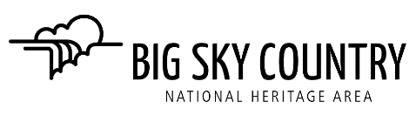

AGENDA - BOARD MEETING
BOARD OF DIRECTORS, BIG SKY COUNTRY NHA, INC.
Wednesday, July 20, 2022

- Call to Order, Welcome Guests and Roll Call Jane Weber

- Disclosure of any Conflicts of Interest on this agenda Board Members

- Jerry Lehman resignation Board Members 1 minute
Decision: Acceptance of Jerry Lehman’s resignation from the BSCNHA board of directors.

- BSCNHA Bank Account Jane Weber 5 minutes
Decision: Approval of Pam Guschausky’s appointment as BSCNHA treasurer effective immediately and authorizing her as the official signatory on the BSCNHA bank account so she can deposit funds and write checks on behalf of the organization.

- Projects Committee Report Jane Weber 5 minutes
Information: Approval of five Partner Project Fund grants
- Neihart fire bell tower
- Fort Benton Episcopal Church stained glass window demonstration and brochure
- Fort Benton Mandan Keelboat Restoration
- Great Falls BID ArtsFest mural
- Little Shell Powwow Presentation by Tribal Elder

- Status of BSCNHA Process Jane Weber 5 minutes

- Little Shell Powwow
Action Item: for August 27-28 Little Shell Powwow in Centene Stadium Jane Weber 5 minutes
Committed: Pam, Mark, Gayle, Jane, Ken have offered so far. Need two people
for each shift. Schedule to be provided at this meeting for signups.

- Motion to Adjourn
Next meeting is Monday, August 22nd at 4:00 p.m.

